Pre-Procedure Documentation for a 3 Hour GTT in Epic

- Double click the 3 Hour GTT patient on the Lab schedule to open the visit encounter.
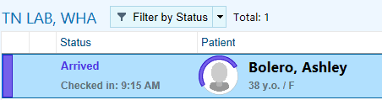
- Click Chief Complaint  to open the section for documentation.
- Type abnormal glucose and press enter.
- Click Close. 
- Click the blue arrow on the right side of the screen to open the Progress Note. 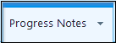
- In the blank note type .WHA3HRGTTLABASSISTANT and press enter.
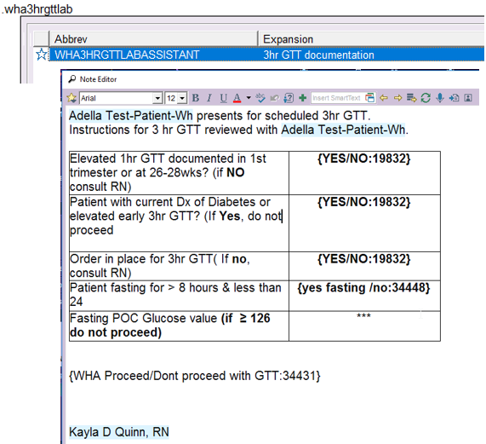
- Press F2 to work through the checklist and ensure it is appropriate to receive the 100g Glucola
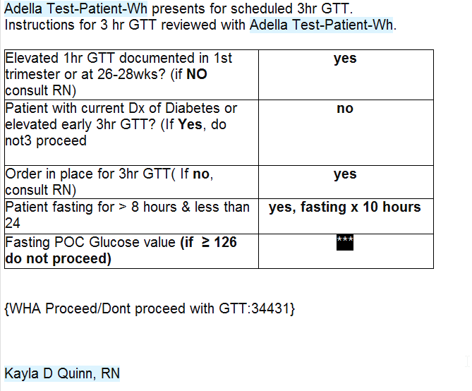
- Leave the note open or pend note, until you know the patient’s fasting glucose.

Drawing the POC Fasting Glucose & Specimen that will be sent to the Lab
- Process Order in Orchard -- Will Print out all 6 labels at time of processing the order with the time of processing -- **Printed out times on the label will need to be manually changed to reflect the time of actual draw**
  - Master Label – Affix to Daily draw sheet
  - Point of Care Label – Lavender Tube
  - Fasting – 00 – Grey top Tube
  - 1hr – 01 – Grey top Tube
  - 2hr – 02 – Grey top tube
  - 3hr – 03 – Grey Top Tube

- Grab your Lavender & one Grey top tube.
- Draw Lavender tube FIRST (only need to fill approx. ½ way) THEN Grey top tube (fill). Invert both specimens gently 8-10 times.
- Label Lavender tube with “Point Of Care/Extra” label & Grey Top Tube with “Fasting-00” orchard label.
- Point of Care Testing from Lavender Tube -
  - Use Smear Safe device to pierce the cap of the lavender tube to obtain the POC fasting value – refer to Standard Operating procedure for Accuchek use.
  - Once value obtained, discard lavender tube in sharps container. – If patient has questions about discarding sample – There is an additive in the tube, so need to get enough blood in the tube to avoid compromising the sample.
- Reserve Grey Top Tube to be sent to lab after final lab draw is obtained.
- Once you know their fasting glucose, enter the value into the checklist and press F2 to continue to the next field.
- If patient’s fasting glucose was less than 126, then will give the patient the Glucola to drink and document the start and stop time. Needs to finish within 5 minutes.
  - Affix patient label to a 3hr timer – set 1hr, 2hr & 3hr draw times to reflect due times from time patient starts glucola.
  - Give patient ½ sheet of paper with written out due times for their awareness of draw times as well.
  - The note can then be pended until either, all four draws have been completed, or if the patient runs in to any issues with vomiting/wants to terminate testing, at which point that would be the option chosen and a clinical staff member would take over the documentation. If no other clinical staff member involvement needed, jump down to last page for instructions on final completion steps needed (within epic).
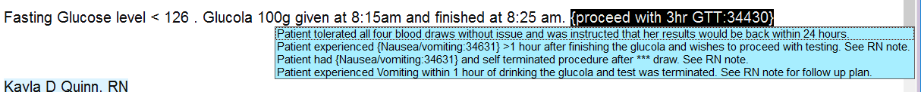

Fasting Glucose > 126 (diagnostic for GDM)
- If patient’s fasting glucose was greater than 126, then the Glucola would not be given. If patient does not have a same day appointment with their clinician, patient will be made aware that a nurse will be calling them to review next steps. Call Nurse Backline for quick access to RN – ext. 1888 to give awareness that note being routed to them for follow up as a CC’d Chart. *Ensure all wild cards in documentation completed prior to routing*
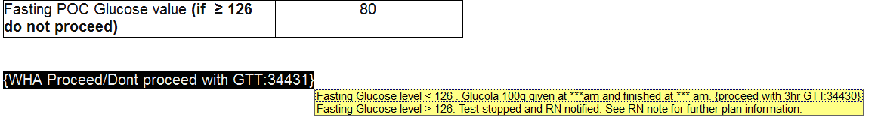

MA/LPN/RN Documentation Related To Fasting Glucose > 126 (Diagnostic of GDM)
- Start a new progress note by clicking Create Note in the Progress Notes section.
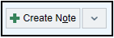
- Type .WHA3HRGTTELEVATEDFASTING into the blank note

- There will be a few Wild Cards & Smart Lists to F2 through to complete this documentation.
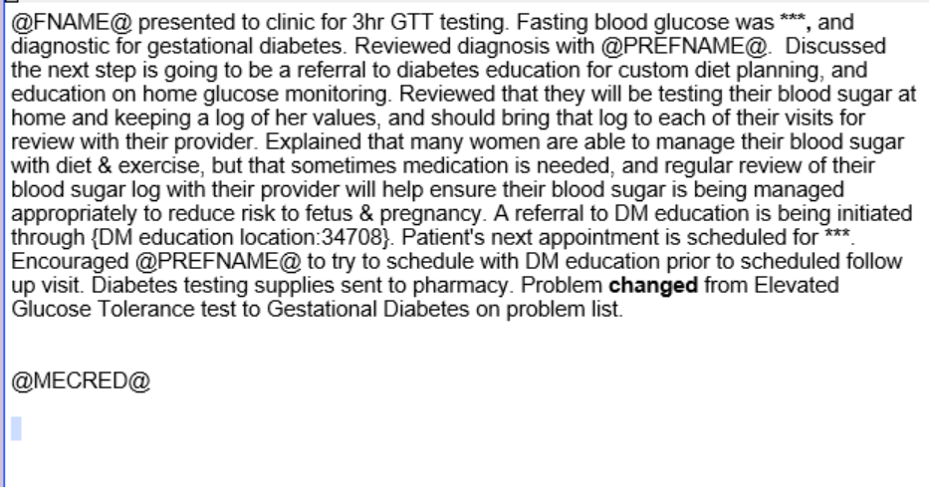
- The other thing the MA/LPN/RN needs to do is Change the problem from Elevated Glucose Tolerance Test to Gestational Diabetes, and need to specify if diet, insulin or oral med controlled (most of the time it will start as diet controlled), then click Accept to make the change, and then Accept again to save the change.
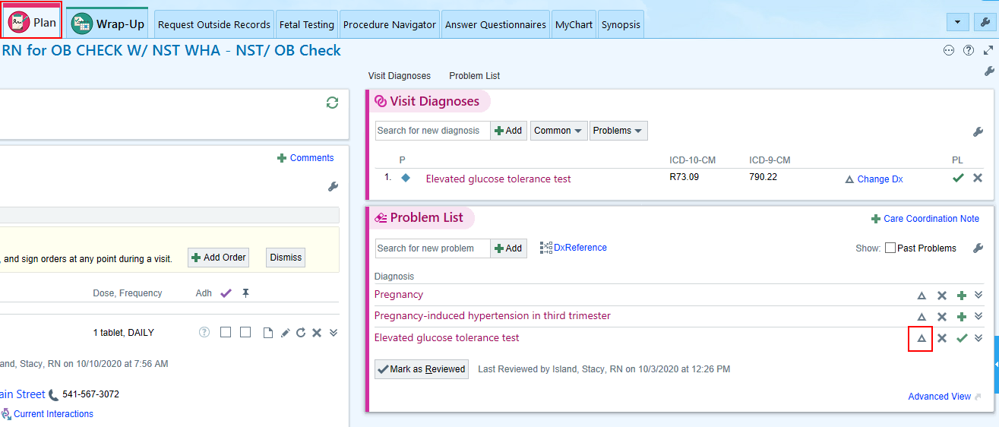
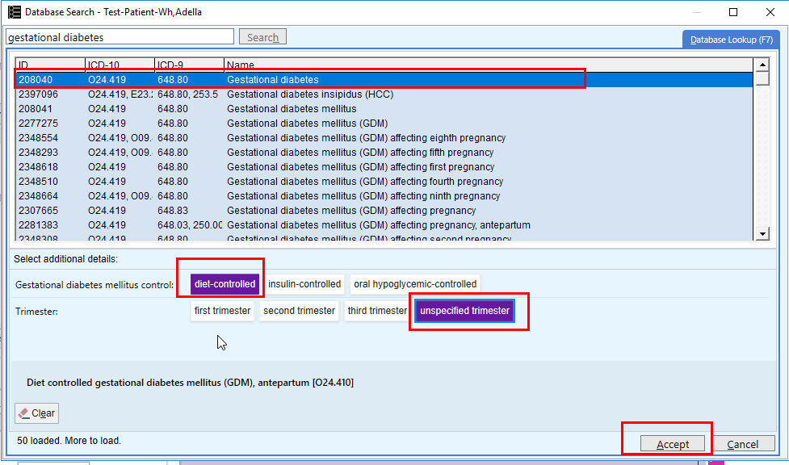

Management of Nausea &/or Vomiting During 3hr GTT
*Goal is to help patient complete test*

- If patient experiences emesis prior to 1hr draw- test will need to be terminated. Patient given option to repeat test with Zofran ahead of time
  - If desired to try again with pre-medication send message to Advice Pool to send Rx. Send patient to front desk to reschedule at least 24 hours in the future, but as soon as possible.
  - Patient declines to repeat test – Send message to provider & Advice Pool for alternative recommendations & follow up.
- If patient is experiencing nausea ONLY or has vomiting between 1- 3hr draws, okay to proceed if patient feels able. Clinical Staff Member (MA/LPN/RN) may offer:
  - Lying down in exam room
  - Cool cloth
  - Zofran 4mg dissolvable tablet if desired & no allergies.
- If patient is unable to complete all 4 draws or desires to terminate testing due to feeling poorly, follow above workflow for rescheduling/Notifying provider and RN team.

Nausea & Vomiting Documentation
- Start a new progress note by clicking Create Note in the Progress Notes section.
- Type .WHA3HRGTTNAUSEA into the blank note
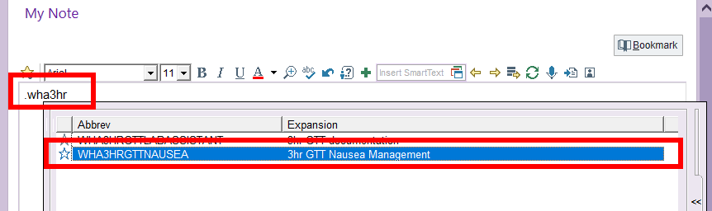
- This smart phrase will provide cascading options for documenting the interventions for treating the nausea & vomiting and whether or not the patient completes the test or wants to terminate the test.
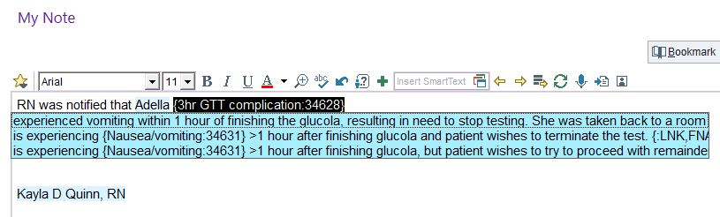
- If you are managing a patient for nausea/vomiting, we should be checking their vitals (BP, HR, RR) as a baseline, prior to discharging home and PRN throughout testing if worsening symptoms. Review abnormal values with clinician.
  - These can be documented in the rooming activity; and clicking New Set of Vitals with each evaluation.
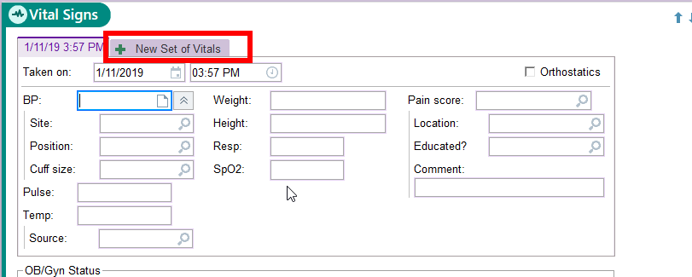
  - If providing Zofran, will need to order the Zofran through the Preference List as a Clinic-Administered Med, and then documented in the MAR (you will need the lot & NDC # so don’t throw away the package).
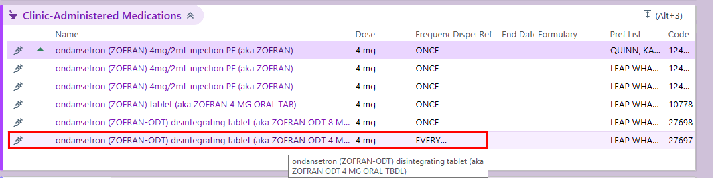
  - To add a diagnosis code click the two gray rings below the medication OR Dx Association.
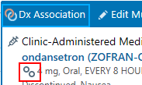
  - Find the diagnosis code Nausea and vomiting in pregnancy by searching in the Add diagnosis box.
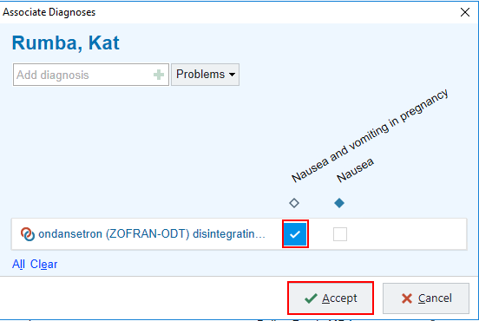
  - To sign the order, change the Frequency to Once, then click Accept and Sign Orders.
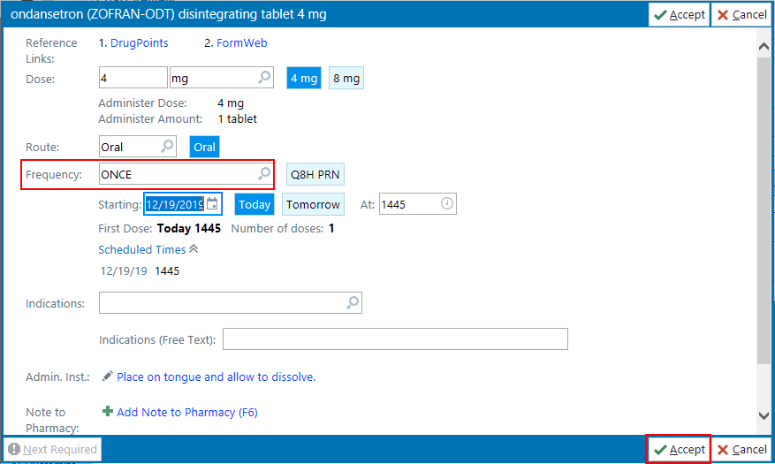
  - Click the MAR activity to go to the Medication Administration Record.
  - Find Zofran and click New Administration.
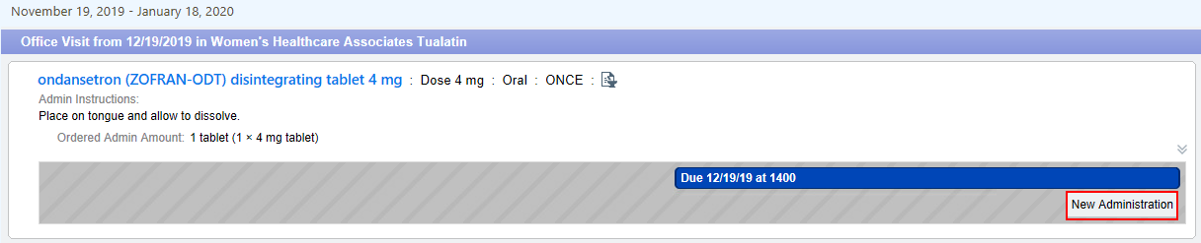
  - Enter the NDC #, the Lot #, and the Billing Provider (if blank), then click Accept.
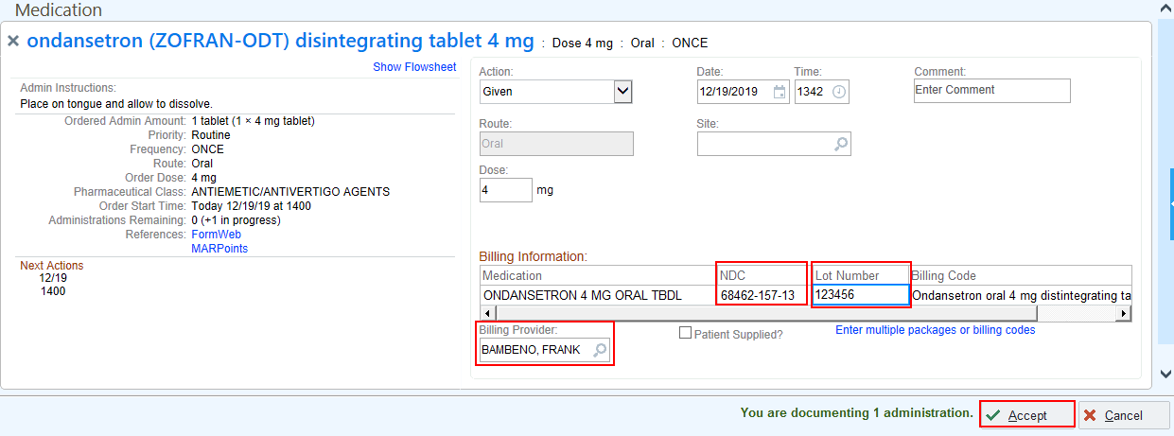

Completing the Encounter

- Complete remainder of smart phrase within documentation field.
- Send All 4 Grey Top Tubes to the central lab in ONE specimen bag per patient (if test completed)!
- The final component needed to close/sign the encounter is the Level of Service within the Wrap Up 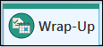 activity.
- Click RN NC chk (PR Nurse Visit No Charge) and then enter in the Authorizing Provider, which would be the provider on the 3hr GTT order.
- Sign the encounter by clicking Sign Visit  once documentation is completed.

